¶ (11 pt)
¶ (11 pt)
¶ (11 pt)
instructions for authors
(12 pt bold with capital letters)
¶ (11 pt)
First Name Surname¹, First Name Surname¹ and First Name Surname² (12 pt bold)
¶ (11 pt)
¹University of Kragujevac, Faculty of Engineering, Sestre Janjić 6,
34000 Kragujevac, Serbia, E-mail address (10 pt)
²University “Lucian Blaga” of Sibiu, Department of Industrial Machines and Equipment, Emil Cioran 4, Sibiu, Romania, E-mail address (10 pt)
¶ (11 pt)
¶ (11 pt)
Key words (TNR 10pt, bold, italic): List 5-6 keywords (10 pt).

If your paper is accepted to the IRMES 2019 conference, then the extended abstract is the version that will be published in the conference Proceedings of Extended Abstracts printed format. This means that the extended abstract needs to contain all the information that the author feels is essential that a reader of the full paper is made aware of. Please take into consideration that the main sentences of the abstract must present the following aspects: placing the work in context (briefly review of the pertinent literature); the purpose of the work (present the scope and objectives of the paper and state the problem); explaining what was done (the methodology must be clearly stated and described in sufficient detail; the author shall explain the research question, describe the research framework and the method applied in detail and why the chosen method are suited for the problem; it should be highlighted why the research question is relevant to theory and practice); indicating in detail the main results/findings of the work should be an essential part of the extended abstract; the most important conclusions of the paper (principles and generalisations inferred from the results, theoretical and/or practical implications of the work, recommendations).
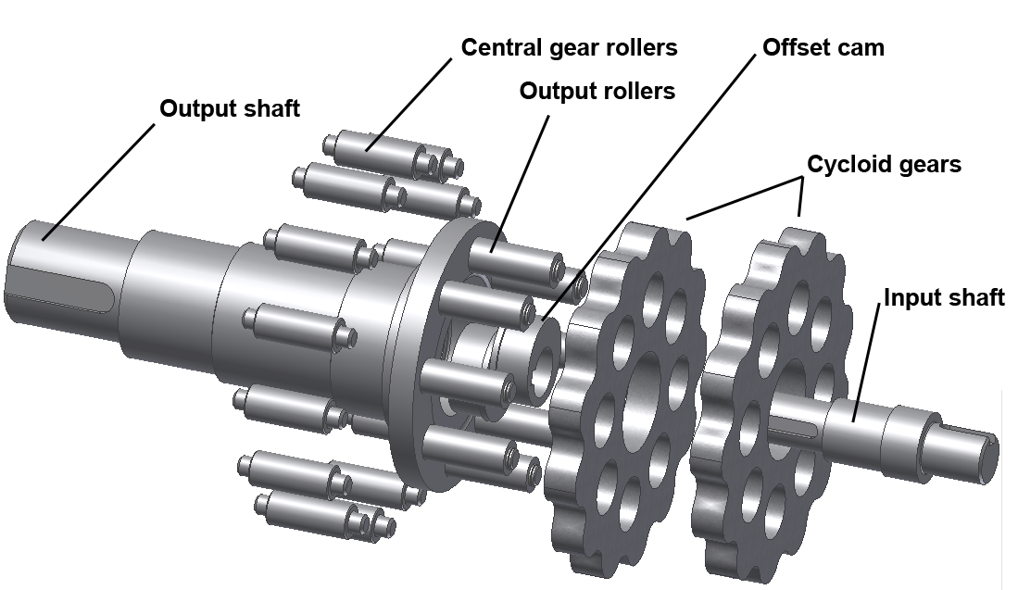

Figure 1. Caption of the figure 1
The extended abstract shall be written in 10-point Calibri (Body), text should be justified and single line spacing. No lines between paragraphs. Extended abstracts can contain figures/images and tables and they should be centered. Figures and images should be numbered and figure/image headers should be placed under the figure or image (Figure 1. Caption of the figure 1); as for the tables, they should also be numbered and the table header should be placed at the top (Table 2. Caption of the table 1). Page format should be 165 mm width and 235 mm height, with margins 17 mm wide from the right, left, top and bottom. Pages will be numbered, currently 1 and 2. The extended abstract should be written clearly and in good English and must be written on two pages.

Table 1. Instructions for authors
No | Item | Explanation
 | Paper size | Use format: 165 mm width and 235 mm height. Only this extended abstract size will be accepted.
 | Length | The extended abstract must be written on two pages.
 | Margins | Use mirror margins, and leave 17 mm wide from the right, left, top and bottom.
 | Fonts | The 10 point Calibri font, text should be justified and single line spacing. No lines between paragraphs.

Some equations from the paper could also be placed in extended abstract. They should be centered, but should not be numbered.
The extended abstract must be sent, as DOC or DOCX file, to the conference organizer by E-mail: irmes2019@kg.ac.rs by Thursday August 1st 2019.

Acknowledgments. This work was funded by the Ministry of Education and Science of the Republic of Serbia under the contract ABC12345.

